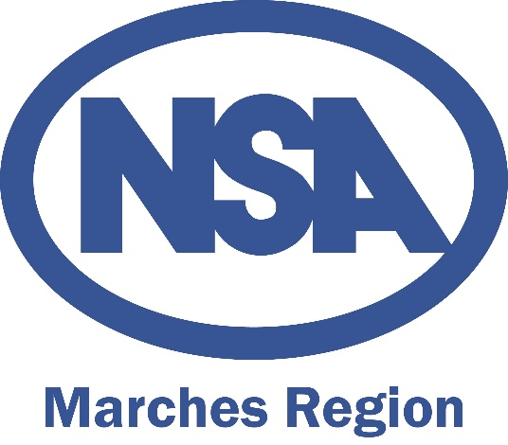

NSA Marches Region Annual Members Meeting 2017
Wednesday 22nd November, 7pm
Stratford Livestock Market, Warwickshire.
Minutes

Present:
Hannah Park, Antony Spencer, Richard Vines, Nick Hart, Hilary Mann, Henry Dunn, Carol Dunn, Ellen Helliwell, Paul Heritage, Reg Arch, Roger Carter, Mike Carter, Jo Lawrence, Tom Price, Lorna Hendey, Amy Fawcett, Duncan Wyatt, Anthony Warington, David Harrison, Tom James, Russel Keepence, Guy Doleman, Peter Sessford, George Scrivens, Rollo Deutsch, David Talbot, Martin Talbot, Angela Russel, Melanie Bent, Robert Hutchings, Dave Gauld, Anne Beaumont, John Baeumont, John Brigg, Sue Farquhar, Mike Credland.
1. Welcome and apologies
Antony opened the meeting and welcomed everyone to the venue. Apologies were received from
Charlotte Underwood, Philippa Ball, Andrew Powers, Angela Weston and Kevin Harrison.

2. Minutes of the previous Annual Members Meeting and matters arising. There were no matters arising from these minutes and Antony signed them as a true and correct record.

3. Chairman’s Report: Antony gave a report and said he had enjoyed time in the position so far. He said a highlight had been the Next Generation Shepherds Training Day which was well attended by young people and supported by members of the committee and the region had set out what it wanted to achieve by holding this. Antony thanked outgoing Trustee Mike Credland for his hard work in the position during the past six years. He thanked all regional members and non-members for coming to the meeting and said a regional farm walk is planned for the spring, more details to follow.

4. Treasurer’s Report: Hannah gave a treasures reported that funds were healthy, with the current balance standing at £13,077 on the day. The main of regional funding comes from HQ as part of an agreement around the biennial sheep event, with additional activities like the Next Generation shepherds day brining in a small amount in sponsorship.

5. Election of regional officers:
a. Re approval of Chairman: Antony was unanimously approved by the committee to continue as Chairman. Mike Credland proposed. Richard Vines seconded.
b. Appointment of Vice Chairman: Antony proposed a working group of Henry Dunn, Richard Vines, Andrew Powers, Reg Arch continue as Vice Chairman. Mike Credland proposed. Ellen Heliwell seconded.
c. Re approval of Secretary: Hannah was unanimously approved by the committee to continue as Secretary. Henry Dunn proposed. Richard Vines seconded.
d. Re approval of Treasurer: Hannah was unanimously approved by the committee to continue as Treasurer, with support from NSA Head Office. Mike Credland proposed. Henry Dunn seconded.
e. Nomination of the regional Trustee/Board Member: Antony reported the committee had put forward Henry Dunn. There were no other nominations received. Mike Credland proposed. Richard Vines seconded.

f. Election/re-approval of regional representatives on the NSA English Committee: Committee members currently representing the region were unanimously approved by the committee to continue doing so. Richard Vines proposed. Henry Dunn seconded.
Antony Spencer (served one of three years).
Mike Credland (served two of three years).
Kevin Harrison (served three of three years).

8. Election of new committee members and endorsement of current members: There were no new members put forward for election onto the committee.

9. Any other business: There was no other business.

The meeting will be followed by:
An update from Hannah Park, NSA Communications Officer alongside Marches Region Secretary, on the NSA Next Generation Ambassador programme. This was followed by a presentation from Duncan Wyatt, Senior Market Intelligence Analyst at AHDB Beef & Lamb, on some of AHDB’s key work areas as Brexit approaches, looking at import and export expectations, threats, opportunities and challenges for the sheep industry.

